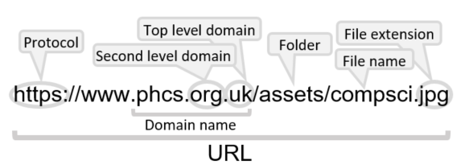

Name:

Networks: Internet and Ethernet

|  |  |  |  |
| --- | --- | --- | --- |
| **D** | | **TCP/IP** | |
| **1** | **Application layer** | | Makes data readable to the senders and recipients by using protocols like HTTP, FTP, SMTP etc |
| **2** | **Transport layer** | | Breaks down data into packets and applies appropriate headers and trailers according to TCP |
| **3** | **Internet layer** | | Adds sender’s and recipient’s IP addresses according to Internet Protocol |
| **4** | **Data link / physical layer** | | Breaks data into frames according to Ethernet protocol for passing between nodes of a network and between different networks |

|  |  |
| --- | --- |
| **C** | **Ethernet** |
| **Frame** | Data unit to be sent over Ethernet, including source and destination MAC address and error checking. Sent to all devices connected on a segment. Created by hardware |
| **Segment** | Section of an Ethernet network on a shared medium |

|  |  |  |
| --- | --- | --- |
| **B** | **Domain naming** | |
| **Domain** | | A group of computers on a network which are administered together |
| **Domain Name System (or Server)** | | A server which contains a list of IP addresses and their associated URL |
| **Top level** | | The last suffix in a URL |

|  |  |  |  |
| --- | --- | --- | --- |
| **A** | **Key vocab** | | |
| **Hypertext Markup Language** | | HTML | Language which websites are written in, and which a browser interprets |
| **Cascading Style Sheets** | | CSS | File which adds additional styling to HTML files |
| **eXtensible Markup Language** | | XML | Text-based data file for use with HTML |
| **Uniform Resource Locator** | | URL | A memorable name for a domain |
| **Internet service provider** | | ISP | Company which provides access to the internet |
| **Host** | | A computer which stores a resource | |
| **Service** | | Software which is available to use via a network | |
| **Dynamic IP address** | | Temporary IP address assigned by DHCP server on connection to a network | |
| **Static IP address** | | Permanent IP address assigned to a computer by the ISP | |
| **Virtual machine** | | A machine (or representation of one) used through the cloud | |
| **Virtual network** | | A network including virtual machines | |